OOD Group C

**Team members:**

Blendi Kovani

Imran Touqi

Adam van de Merve

Ivan Ivanov

Contents

Class diagram 3

Sequence diagrams 4

# Class diagram

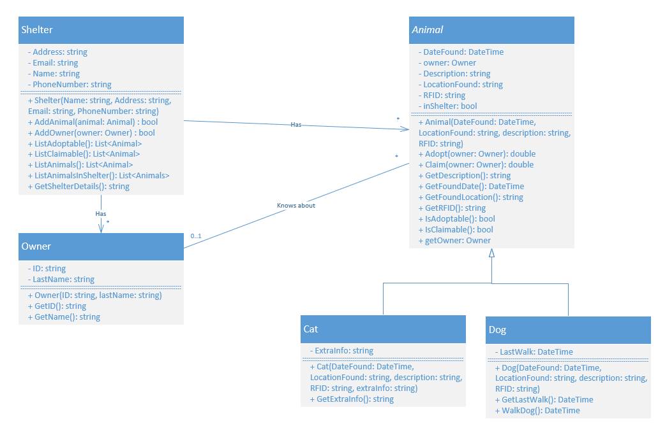

# Sequence diagrams

Displaying a list of adoptable animals

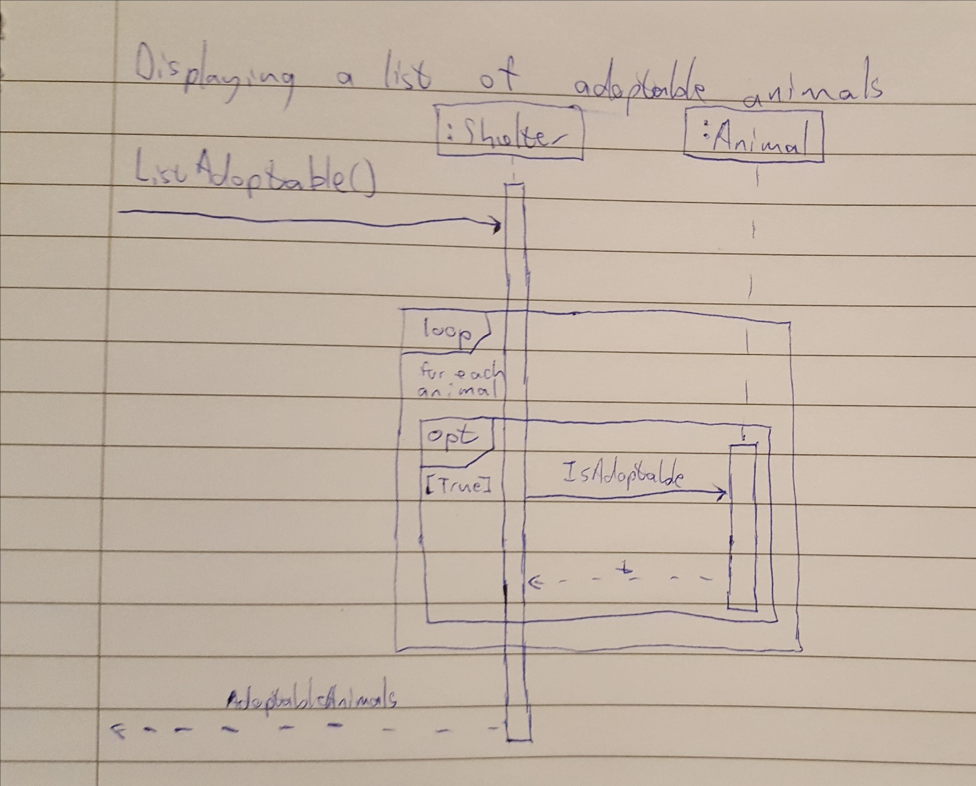

Getting a specific animal

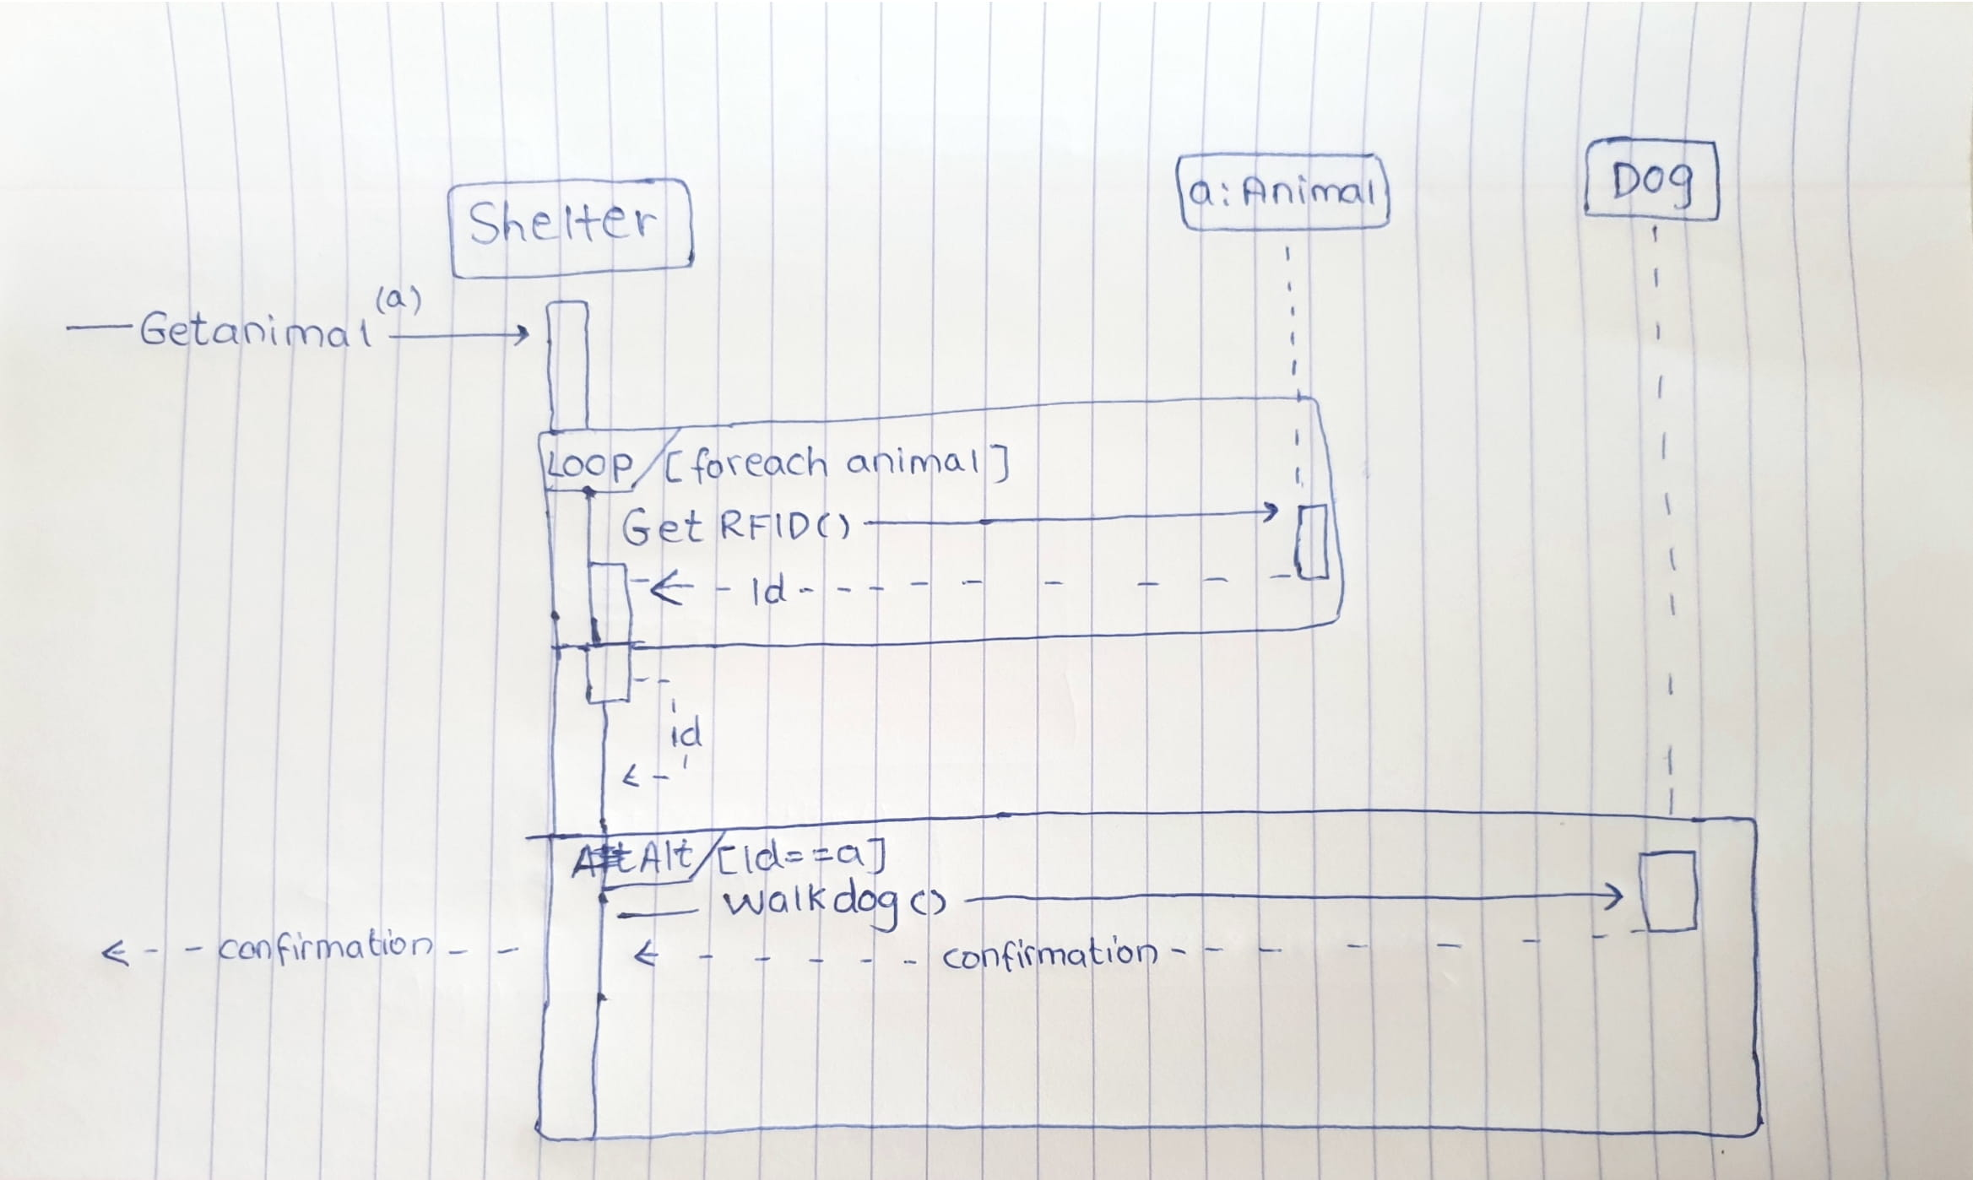

Checking animal details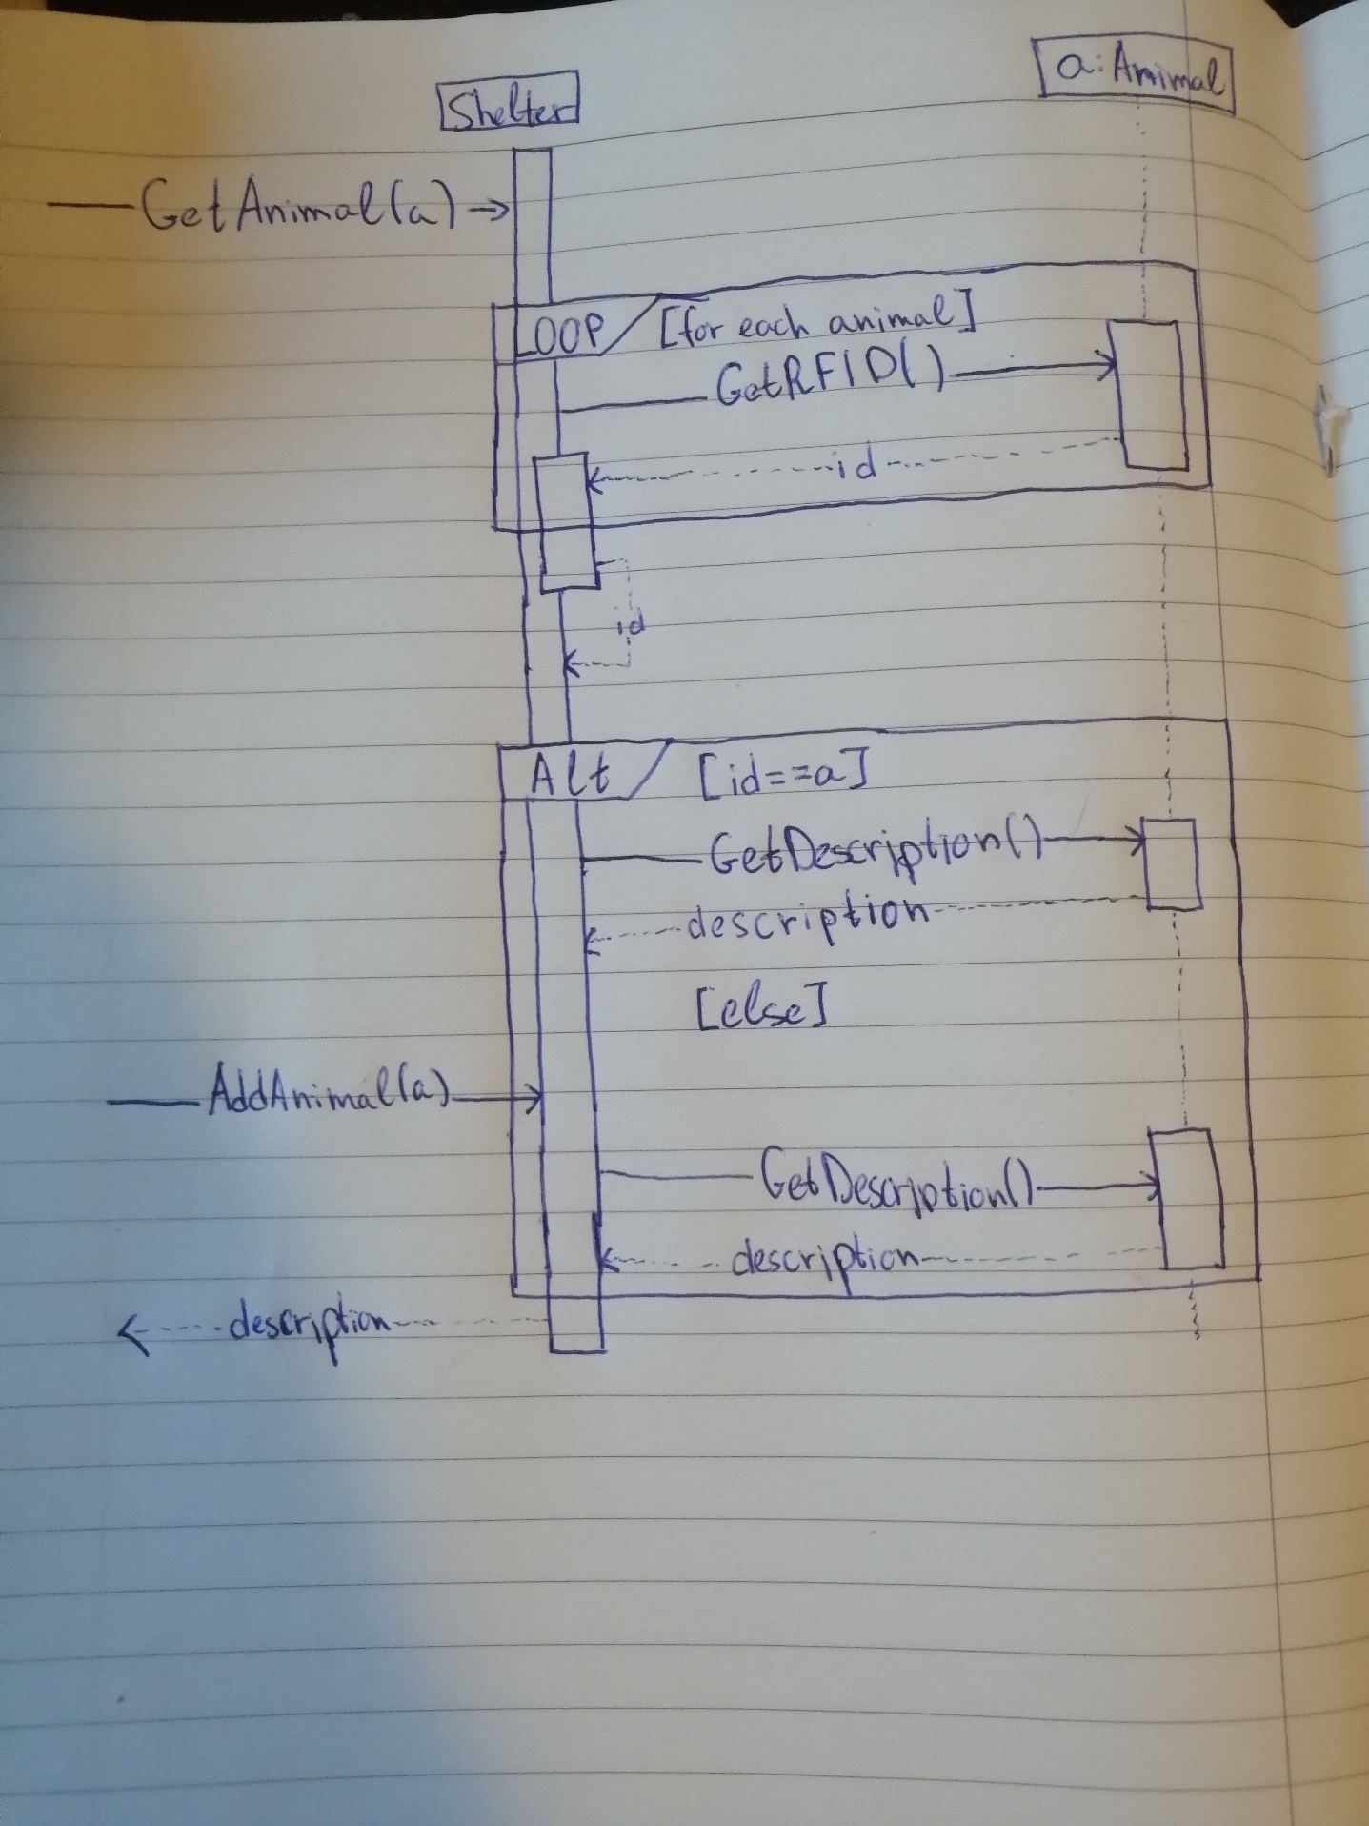

List claimable animals

